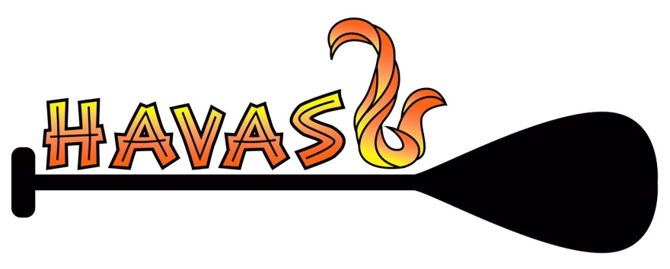
Lake Havasu City Outrigger Canoe Club
Visitor WAIVER Agreement

In consideration of the services of Lake Havasu City Outrigger Canoe Club and Racing Team, Inc., their agents, owners, officers, volunteers, participants, employees and all other persons or entities acting in any capacity of their behalf (hereinafter collectively referred as “LHCOCC”), I hereby agree to release, indemnify and discharge LHCOCC, on behalf of myself, my children, my parents, my heirs, assigns, personal representative and estate as follows:

- I acknowledge that my participation in paddling an outrigger canoe entails known and unanticipated risks that could result in physical or emotional injury, paralysis, death, or damage to myself, to property, or to third parties. I understand that such risks simply cannot be eliminated without jeopardizing the essential qualities of the activity.

The risks include, among other things: boat capsize; tidal conditions and currents; travel in remote areas; collision with objects or other watercraft; prolonged exposure to cold water, hypothermia, accidental drowning; illness in remote areas; exposure to sun, strong wind, cold, storms, large waves, eddies and whirlpools, and lightning; aggressive and/or poisonous marine life; wrist, arm, shoulder and/or back injuries; slips and falls while getting in and out of the canoe; the launching and loading of canoes process; and rapidly changing adverse weather and water conditions.

Furthermore, LHCOCC organizers have difficult jobs to perform. They seek safety, but they are not infallible. They might be unaware of a participant’s fitness or abilities. They might misjudge the weather, the elements or the terrain. They may give inadequate warnings or instructions and the equipment being used might malfunction.

- I expressly agree and promise to accept and assume all of the risks existing in this activity. My participation in this activity is purely voluntary and I elect to participate in spite of the risks.

- I hereby voluntarily release, forever discharge, and agree to indemnify and hold harmless LHCOCC from any and all claims, demands, or causes of action, which are in any way connected with my participation in this activity or my use of LHCOCC’s equipment or facilities.

- Should LHCOCC or anyone acting on their behalf, be required to incur attorney’s fees and costs to enforce this agreement, I agree to indemnify and hold them harmless for all such fees and costs.

- I certify that I have adequate insurance to cover any injury or damage I may cause or suffer while participating, or else I agree to bear the costs of such injury or damage myself. I further certify that I am willing to assume the risk of any medical or physical condition I may have.

- In the event that I file a lawsuit against LHCOCC, I agree to do so solely in the state of Arizona, and I further agree that the substantive law of the state shall apply in that action without regard to the conflict of law rules of that state. I agree that if any portion of this agreement is found to be void or unenforceable, the remaining portions shall remain in full force and effect.

By signing this document, I acknowledge that if anyone is hurt or property is damaged during my participation in this activity, I may be found by a court of law to have waived my right to maintain a lawsuit against LHCOCC on the basis of any claim from which I have released them herein. I have had sufficient opportunity to read this document. I have read and understood it, and I agree to be bound by it terms.

***********************************PLEASE NOTE SAFETY REQUIREMENT***************************************
Participant MUST wear a Personal Floatation Device (PFD) if they are not able to swim or tread water in the event of a capsize situation.
Participant acknowledgement required __________________ (Initials) Date__________________

Signature of Participant: Print Name:

Address: Street City State/Zip

Phone #’s: Home: ____________________ Cell: ________________________ DOB: _______________________ M/F:

Emergency Contact: Phone:

PARENT’S OR GUARDIAN’S ADDITIONAL INDEMNIFICATION (Must be completed for participants under the age of 18)

In consideration of (print minor’s name)(“Minor”) being permitted by LHCOCC to participate in its activities and to use its equipment and facilities, I further agree to indemnify and hold harmless LHCOCC from any and all claims which are brought by, or on behalf of Minor, and which are in any way connected with such use or participation by Minor.

Parent or Guardian Signature:
Print Name: Date:

(Version Jan 2016)

