LHCOCC General Meeting
January 2, 2020 at 5:30pm
Agenda and Minutes
Meeting called to order: Time: 6:14 pm
In attendance: Dr. Paul, Angie, Jeanne, Phil, Jackie, Mary, Cathy, Gary, Randy, Diane, Anita, Gary, Sherrie, Ken, Dick, Susan and Michele.
Acceptance of Minutes from 10/12/2019 Meeting 1st: Angie - 2nd: Jackie
Minutes of all meetings are located on our website at lhcocc.com/meeting-minutes
President’s Welcome: Thank you Jeanne for your hospitality. Great food and great company.
Our Mission and Vision Statement:
Jan Chisman read our Mission and Vision Statement, which can be found on our website at lhcocc.com/about-contact:
MISSION: To provide educational and recreational Outrigger Canoe paddling programs for all skill levels.
VISION: It is the Vision of LHCOCC to expose people from all walks of life to the ancient cultural traditions and Aloha Spirit which embodies the sport of Hawaiian Outrigger Canoe paddling and racing. We encourage members of our Ohana "family" to grow and develop the skills necessary to become racers if they so desire.

The Board (introduced): Executive Director: Cathy C., President: Jeanne H., Vice President: Jan C., Secretary: Michele K., Treasurer: Diane D., Coach: Gary M., Larry L. At large: Lani H.
Membership Committee: Cathy
SCORA: All year around Members should get a SCORA # and fill the SCORA Smart Waiver on line. Jan brought her laptop so all in attendance could sign up on SCORA. Thanks Jan!
Club Waivers, Artist Waiver, Rules/ Policies / Code of Ethics and Racer intent form to be filled today or before paddling for the first time this yr. We will have the forms at the storage area. For those that were not in attendance and have yet to complete forms, there are forms in the storage box.
Club fees: $325 per year or $30 per month. Discussion on other options. It’s helpful for the club for members to pay the annual fee in full, but certainly not an issue if paid on a monthly basis. There is a discount for an annual payment.
Clothing Committee: Jan
List of Red Jerseys still available, on sale now for $10. Hats and visors also $10. We will get new Jerseys soon.
The new color will be blue and we will have the same graphics. Jan passed around samples of the Short and Sleeveless ($15.00), the Long Sleeve ($20.00) as well as a really cool Jacket ($45.00.) She also had available a sign-up sheet for orders. She wanted everyone to understand they didn’t have to sign up right now, or you could sign up right now and order later. She wanted to get an idea of the volume to order. For the shirts that are ordered, payment is needed by 2/01/2020.
Web site, Facebook, Instagram for Club: Michele Jeanne passed out our new brochures. Pass them onto friends to get our name out there.
Equipment: Gary Now have 3 dollies, 2 good ones. We also have new cones, new padlocks.
Gary states the canoes are in good shape, with the exception of the seats. He will be working on those soon. Also, he is going to do some spot varnishing on the iakus. One of the amas has a paint crack and he, as soon as the weather is better, will do a water test to make sure it’s just a paint crack.
We have new cones and he is planning on buying two (2) more extra-large ones for the race in April.
Coaching: Gary, Larry and Lee, Winter Steersperson Class, 5 members being trained to steer. Lee is now OC2 Coach. Angie is a coach too! Congratulations Lee! You’ll be a great coach.
Gary is pleased with the progress the five (5) steering students are making. They are Anita, Emilie, Michele, Mary and Ken.
In a month or so, Gary is going to hold a Paddling Clinic for the newer members. The Clinic will run about two (2) hours. He will reach out to each new member soon.
SCORA: Dec 14, 2019 Larry attended Jan 12, 2020 Gary will be attending.
Jeanne explained what SCORA is and that our insurance is under the SCORA Insurance Umbrella.
Larry is our SCORA person and Gary is his alternate. Gary is on the SCORA Safety Committee and SCORA has adopted Gary’s Steersperson Program. Yay! Gary.
Past and Future events: Nov 2 ADR race, Nov 16 Paddlefest, Dec 7th Sprint Saturday
Sprint Saturdays: The Board will soon determine the dates for the 2020 Sprint Saturdays so more people can plan ahead and attend. All will be notified soon. Sprint Saturdays have been good practice for us for the upcoming Havasu Heat Race.
Paddlefest: Sherrie and Randy connected with us at Paddlefest and now they’re members. This is an example of how important it is to attend city events whenever possible. Welcome Sherrie and Randy!!
We need to nominate PADDLER of the Year for 2019. We will let you know how and will announce at next Mtg.
Thank you for generosity, we raised ~ $260 and had $340 left from last yr. 6 Kids, $100 spent on each child.
April 4th, 2020 HAVASU HEAT race: Please plan to be in town that day. We will need everybody and trying to have 1 boat race. We will have a list of jobs to be filled. Gary coordinating the Boats. The first Havasu Heat meeting will be on Saturday, February 1st, after recreational paddling. The venue has yet to be determined. There are going to be many tasks to perform and spots to fill, so all club members need to keep that day open.
Racing Schedule from SCORA available on their Web site and ours as well at lhcocc.com/racing. In addition to the race schedule on our website, there is a document called “So, You Want to Race? Read Me!” This document outlines RACE TEAM QUALIFICATION CRITERIA, written by Coach Gary. Check it out!
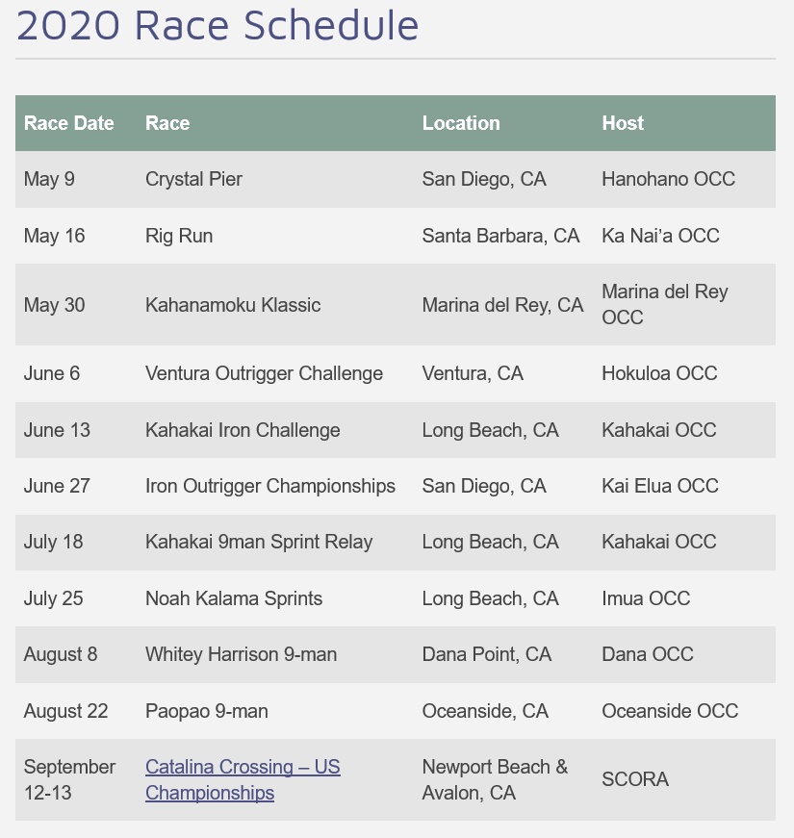
TEAMER: Great tool, use it! If you change your plans to paddle, try to let us know before practice. Some paddlers are not receiving Teamer notifications and we think it’s because we are using the ‘free’ version. We will be moving to the ‘paid’ version soon and hope that will alleviate the problem.
SWIM TEST: We’ll be scheduling the required (every 2 years) tests in June.
Practice time until further notice: Tues, Thurs, Sat at 9am. Be on the beach at 8:45 AM to start at 9am. It is important to BE AT THE BEACH at 8:45 (not 9:00am) to help take the boats out.
Adjourn Meeting time: 7:15pm 1st: Angie - 2nd: Jeanne

